Cannister detail design

DOC. No.: | REV.: 00 |  |  | PRODUCT:
TITLE: About Canister |  |  |  | Project:
Prepared by: | Lewis Chen |  |  | Date:
Remark: | Approval:
Remark: |  | Department | Title |  |  | Signature
Remark: | 1 | Electronic R&D
Remark: | 2
Remark: | 3
Remark: | 4

Revision | Description of Change | Author | Date
00 | Start writing this document about cannister. | Lewis Chen | 2010.07.05

1. Cannister overview 4
2. Cannister mechanical structure 4
2.1. Mechanical action 5
3. Algorithm 5
3.1. EMK-integrated dosing 5
3.2. The Emk and speed nonlinear relationship 5
4. Calibrate the cannister 6
5. Cannister error code define 7
Appendix 8

Cannister overview
Canister is a mechanical which holds different kinds of ingredient (eg. Powder and coffee bean).When you drive the motor, the spindle will push the ingredient out of the canister.
There are many kinds of canister, so the canister mechanical structure is different. Different kinds of mechanical structure result in different friction. In order to make the dosing process precisely, the EMK-integrate dosing algorithm has been used.

Cannister mechanical structure
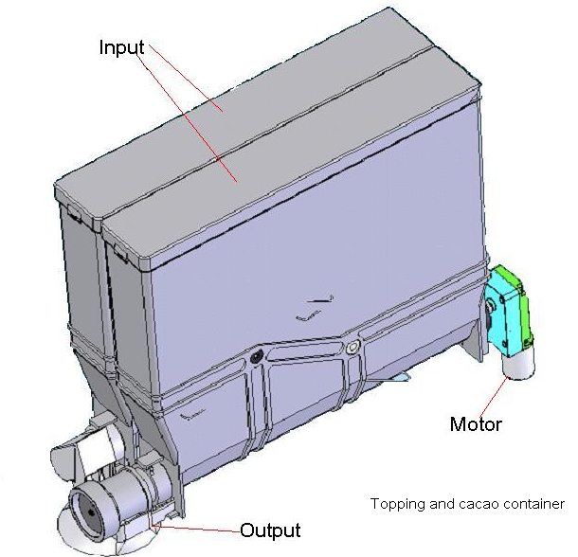
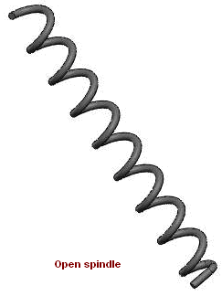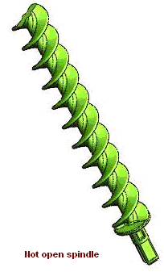
Electronic part: 1 motor, 1 heating Unit (Maybe in the future)
Related sensor: none
Sensor function: none

Mechanical action
The canister mechanical action is simple so far, as it shows in the flow char bellow.
Dispense
(Start motor)
Enough amount (Stop motor)

Algorithm
In practice, the motor speed is various because of the friction which the motor experience keeps changing while driving canister. To fulfilled high accuracy motor control, the EMK-integrated dosing method has been used.

EMK-integrated dosing
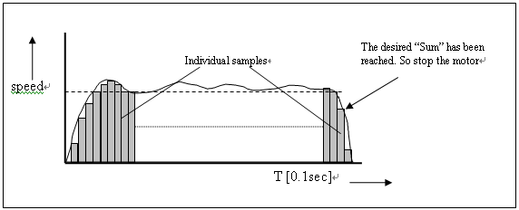
As it shows in the upper figure, the powder amount can be described with the following formula:
Dosage = Calibration * Σ V_{emk} [t]
Calibration is the amount of product produced for every EMK-point. This factor can be got in the machine by turning the motor till setting EMK-points are collected, and prompting the user for the corresponding amount of product
Vemk [t] is the sum of every individual sample.

The Emk and speed nonlinear relationship
The EMK-integrated dosing method assumes that relationship of the BEMF of the motor and speed is linear. But after many test, this hypothesis turns out to be fault.
Here is curve which describes a test result as follow. In this test, different speed has been used to dispense the same amount of powder.
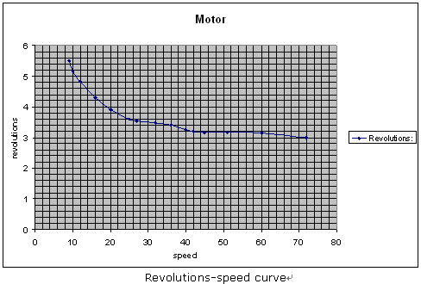
When the motor speed changes from 8 to 20 the slope of the curve is different from the slope of the curve when the motor speed changes from 20 to 40.Also the slope of the curve is nearly the same while the motor speed change from 40 to 70. The revolution which affects the slope of the curve is related to EMK point. So the relationship between motor speed and BEMF is nonlinear.
To overcome the nonlinear relationship, a revise formula which is called revise_emktocollect () has been designed. With this formula, no matter in what speed the canister can dispense powder precisely.

Calibrate the cannister
To make the calibrate process easy to understand, here is a flowchart as follow.

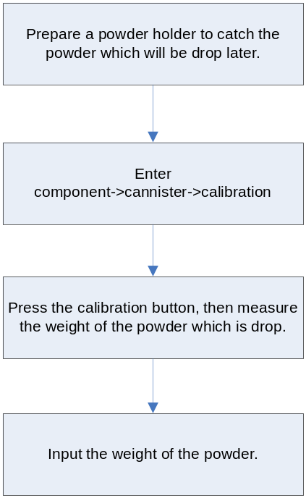

Cannister error code define
EVA error code | Event description | Definition | Is Fatal | Remarks
EDA_01 | Cannister1 not present. | Cannister1 motor isn’t connected. | No
EDA_02 | Cannister2 not present. | Cannister2 motor isn’t connected. | No
EDA_03 | Cannister3 not present. | Cannister3 motor isn’t connected. | No
EDA_04 | Cannister4 not present | Cannister4 motor isn’t connected. | No
EDA_05 | Cannister5 not present | Cannister5 motor isn’t connected. | No
EDA_06 | Cannister6 not present | Cannister6 motor isn’t connected. | No
EDB_01 | Cannister1 block | Cannister1 fault on ingredient dispense mechanism. | No
EDB_02 | Cannister2 block | Cannister2 fault on ingredient dispense mechanism. | No
EDB_03 | Cannister3 block | Cannister3 fault on ingredient dispense mechanism. | No
EDB_04 | Cannister4 block | Cannister4 fault on ingredient dispense mechanism. | No
EDB_05 | Cannister5 block | Cannister5 fault on ingredient dispense mechanism. | No
EDB_06 | Cannister6 block | Cannister6 fault on ingredient dispense mechanism. | No
EDC_1 | Cannister1 dosage error. | canister-1: Motor duration exceeds the specified limit | No
EDC_2 | Cannister2 dosage error. | canister-2: Motor duration exceeds the specified limit | No
EDC_3 | Cannister3 dosage error. | canister-3: Motor duration exceeds the specified limit | No
EDC_4 | Cannister4 dosage error. | canister-4: Motor duration exceeds the specified limit | No
EDC_5 | Cannister5 dosage error. | canister-5: Motor duration exceeds the specified limit | No
EDC_6 | Cannister6 dosage error. | canister-6: Motor duration exceeds the specified limit | No

Appendix
For more information, please refer to the following documents:
Dosage_method.doc
Dosage_method_test_repot.doc

